Jenkins step by step screenshot:
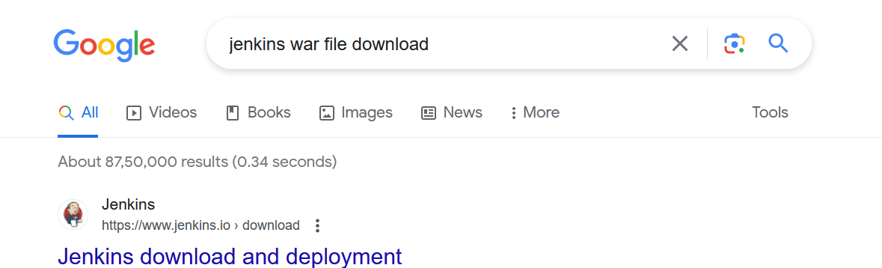
Click past releases in Regular releases
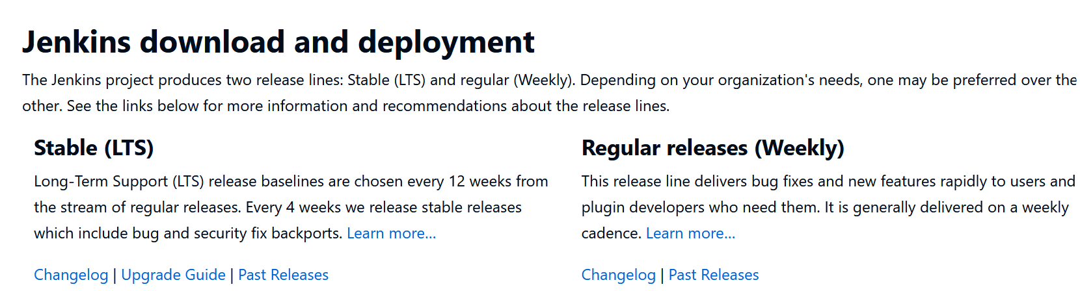
Click 2.387/
Click Jenkins.war
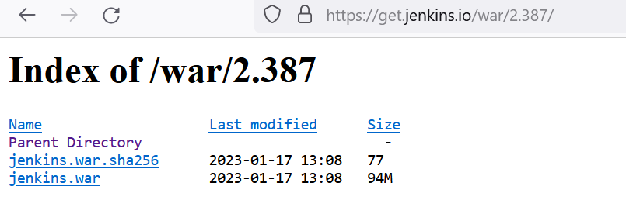
Run Jenkins war file in command prompt, from downloads, copy and paste the Jenkins.war file in “E:\Greens”. Or in any path. Go to that path,
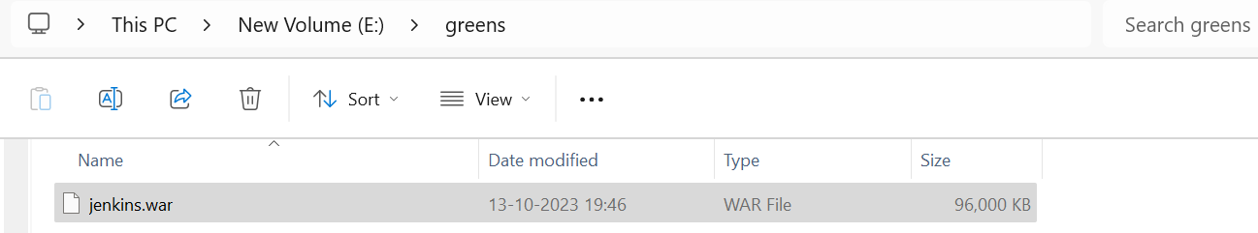
On top type as “cmd” , so command prompt will open
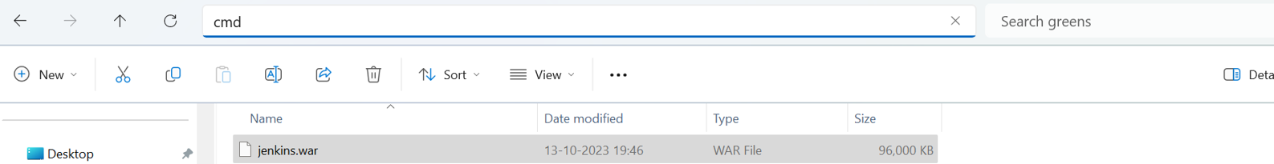
Like this, it will get open
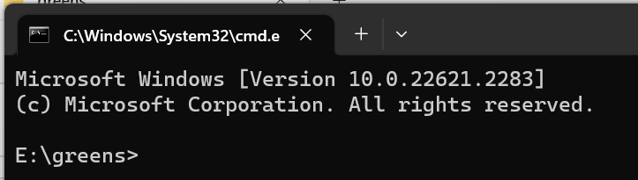
Then type this statement, port number can be in any series of 8080, 8081, etc.,
After giving this it will display many lines, note this line alone.starting with “e9130e44014c4014ad4722c38eae8d9b”
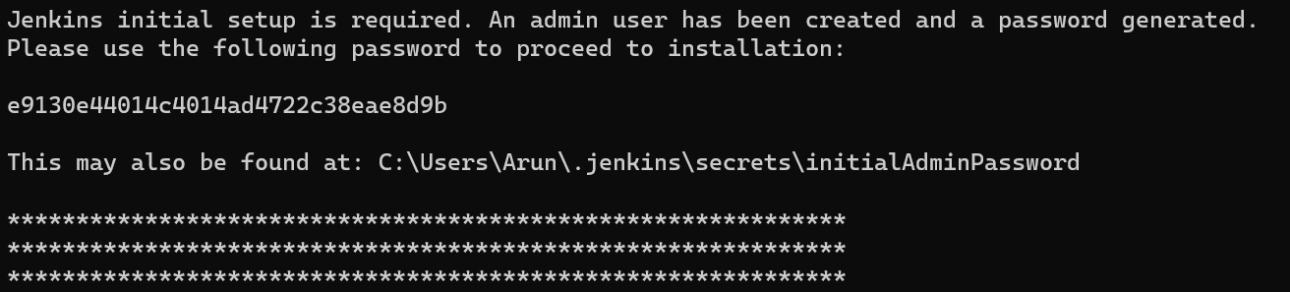
After this go to browser search and give “localhost:8082”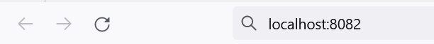
After giving this, it will open like this,
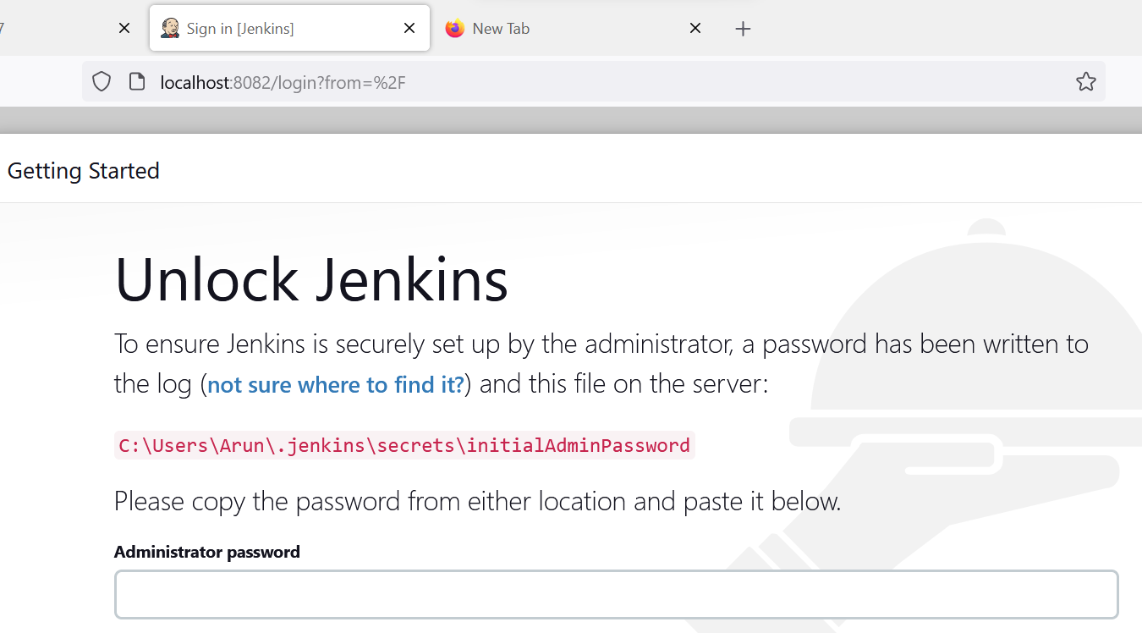
Copy and paste the password “e9130e44014c4014ad4722c38eae8d9b” from command prompt and click continue.
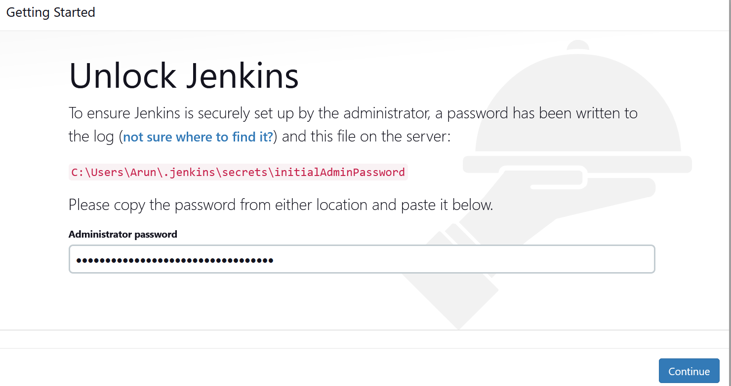
Select “Install suggested plugins”
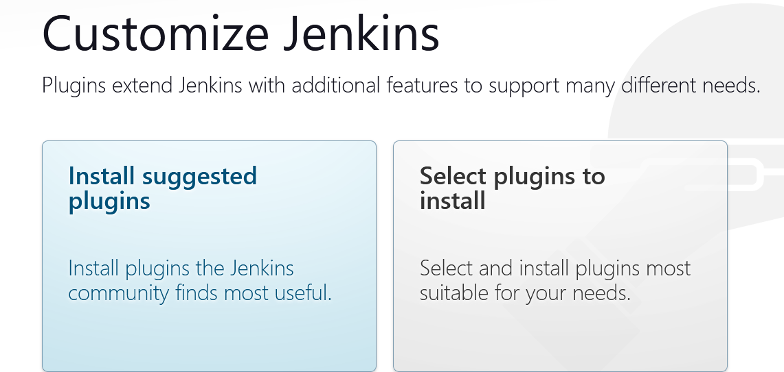
After giving this, it will load like this,
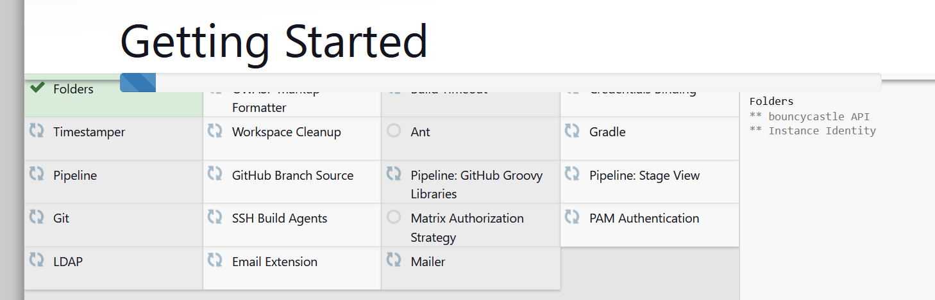
Fill all the details in this page, and give “save and continue”.
Username : “RatnaGreens”, password: “A_ru&12?” , confirm password also same, username “ratnapriya1986”.
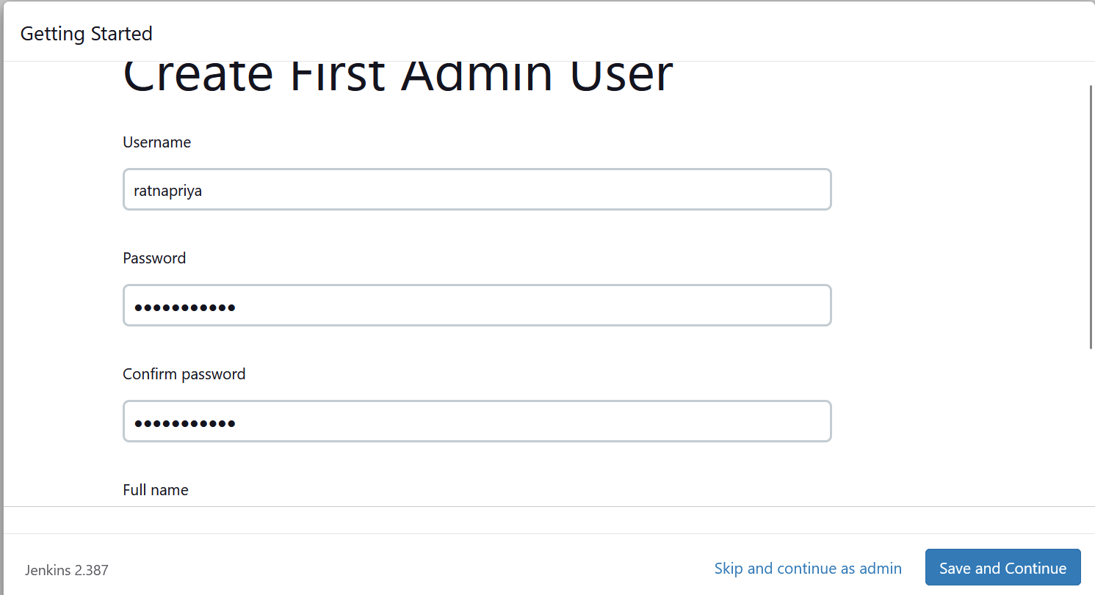
After this , instance configuration show http://localhost:8082/ automatically, then click “save and finish”
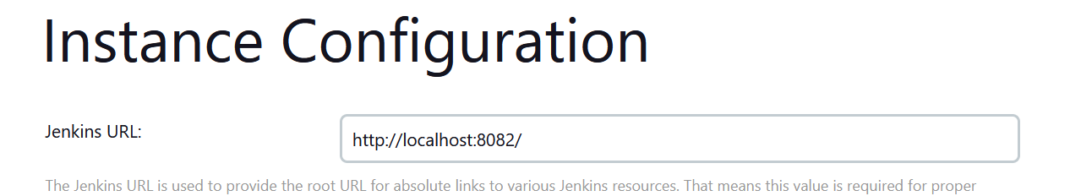
Click “start using Jenkins”
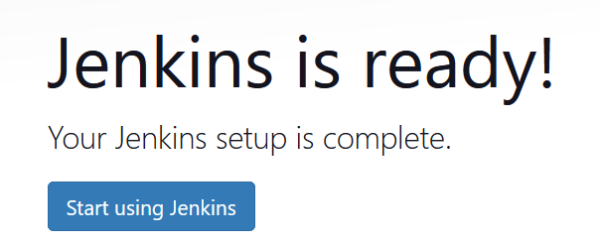
The page will appear like this,
